**Technical Report**

**(Java ECOM)**

# Introduction

This report outlines the technical details of an e-commerce web application developed using Java Enterprise Edition (Jakarta EE), MySQL, HTML, CSS, and Bootstrap. The application provides a user-friendly platform for customers to browse and purchase products online, while also incorporating administrative functionalities for managing inventory and orders.

# Technologies Used

## Backend

### Java Enterprise Edition (Jakarta EE)

The application is built using Jakarta EE, formerly known as Java EE, which is a comprehensive set of specifications and APIs for developing enterprise-level web applications. The Jakarta EE framework provides a robust and scalable architecture for building distributed, multi-tier applications. The following Jakarta EE components are utilized in this project:

* Servlets: Handling HTTP requests and responses, and implementing the application's business logic.
* Java Persistence API (JPA): Handling database operations and object-relational mapping (ORM).
* Java Server Pages (JSP): Rendering dynamic web pages on the server-side.
* Expression Language (EL): Simplifying access to application data from JSP page

## Frontend

### HTML, CSS, and Bootstrap

The front-end of the application is developed using HTML, CSS, and the Bootstrap framework. HTML provides the structure of the web pages, CSS handles the styling and layout, and Bootstrap offers a responsive and mobile-first design with pre-built components and utilities.

## Database

### MySQL

MySQL is used as the relational database management system (RDBMS) for storing and retrieving application data, such as product information, user accounts, and order details.

Database Connected using JPA. Below screenshot how that the database connected.

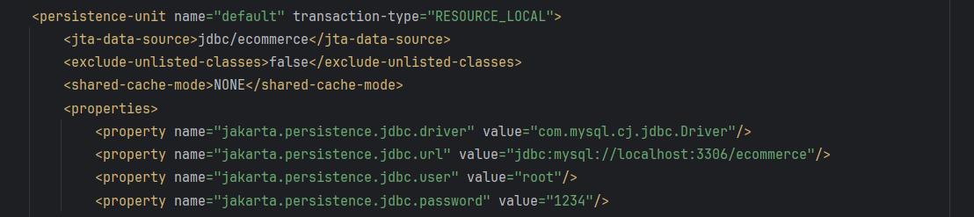

# Application Architecture

The application follows a traditional three-tier architecture, consisting of the presentation layer, business logic layer, and data access layer.

## Presentation Layer

The presentation layer is responsible for handling user interactions and rendering the user interface. It consists of JSP pages and Servlets that process HTTP requests and generate dynamic responses. The front-end is built using HTML, CSS, and Bootstrap, providing a modern and responsive user experience.

## Business Logic Layer

The business logic layer encapsulates the application's core functionality and handles the processing of data. It includes servlets that implement the application's business rules, such as user authentication, product management, and order processing.

## Data Access Layer

The data access layer manages the interaction between the application and the MySQL database. It utilizes the Java Persistence API (JPA) for object-relational mapping (ORM), allowing the application to work with database data using Java objects. This layer includes data access objects (DAOs) that handle CRUD (Create, Read, Update, Delete) operations on the database.

## Key Feature

## User Authentication and Authorization

The application implements user authentication and authorization mechanisms to ensure secure access to the system. Users can register for an account or log in with their existing credentials. Administrative functionalities, such as adding new products or managing orders, and Adding admins are restricted to only authorized users with the appropriate role (“ADMIN”).

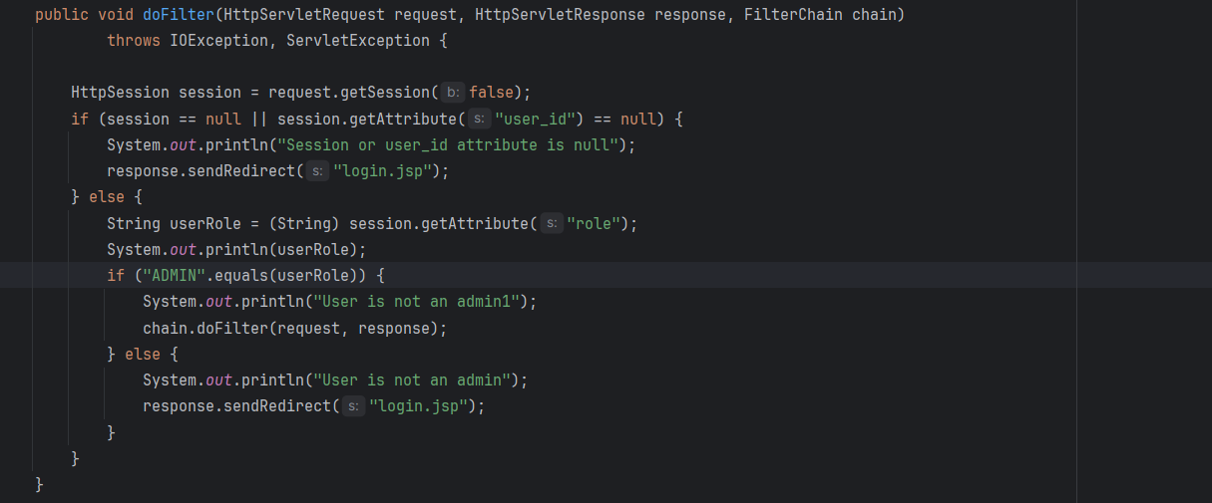

The output will look like this.

### Product Catalog and Shopping Cart

Users can browse the product catalog, view product details, and add items to their shopping cart. The shopping cart persists across multiple sessions, allowing users to continue their shopping experience seamlessly.

### Checkout and Order Processing

Users can proceed to the checkout process, where they can review their cart and complete the order. Upon successful order placement, the application updates the database with the order details and clears the user's shopping cart.

### Admin Dashboard

The application includes an admin dashboard accessible only to authorized administrators. From the dashboard, administrators can perform tasks such as adding new products to the catalog, managing existing products, and viewing order details.

## Security Considerations

To ensure the security of the application, several measures have been implemented:

* Web Filter: A web filter is implemented to restrict access to certain pages based on the user's authentication status. If an unauthenticated user attempts to access restricted pages, they are redirected to the login page.
* Input Validation: User input is validated on both the client-side (using JavaScript) and server-side (using Jakarta EE validations) to prevent potential security vulnerabilities, such as SQL injection or cross-site scripting (XSS) attacks.

## ERD Diagram

The entity relationship diagram is created for this simple web application.

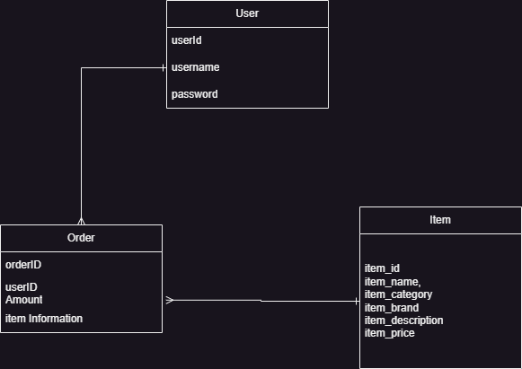

## Deployment and Testing

The application is deployed on a Jakarta EE-compliant web server, such as Apache Tomcat or Payara Server. During the development phase, the application underwent extensive testing, including unit tests for individual components and integration tests for verifying the correct behavior of the entire system.

## Conclusion

This e-commerce web application provides a robust and secure platform for users to browse and purchase products online, while also offering administrative functionalities for managing inventory and orders. By leveraging Jakarta EE, MySQL, HTML, CSS, and Bootstrap, the application offers a modern and responsive user experience, coupled with a scalable and maintainable architecture.

Future enhancements could include implementing additional payment gateway integrations, improving the search functionality, and adding advanced reporting and analytics features for administrators.